Diagram Case Study:

In this project we are going to make a parking management system of AIUB. In AIUB parking lot there near about 900 to 1000 cars and bikes can be park at a time. And there is also a VIP parking lot for VIP. But the problem is in some occasion the space of the parking lot is not sufficient. In this AIUB parking management system we are also finding the solution of the traffic jam of kuratoli road. Beside the insufficient space problem in the parking lot.

To avoid the traffic jam of kuratoli, there will be two kuratoli gate. Kuratoli gate-1 is in the head of the kuratoli road. Which is situated in the bisshoroad. And another one is Kuratoli gate-2 is situated in the front AIUB entry point.

There are CCTV camera in the parking lot. There are watchman in the parking lot who can continuously monitoring that sufficiency place in the parking lot. And inform the guard of kuratoli gate-1 regularly. So first 500-600 cars and bike can entry the parking lot with driver. When it cross the number to 400. Those who are coming with the driver they will not entry the university from their car. They have to drop in the front of kuratoli gate-1 and they will use battery mini car service to students, faculties, staffs, guardians. Those who are coming outside of the kuratoli without car doing the same as using the battery mini car.

For those who are entering with car with their driver. The driver have to take a card which is hold the id information of student, faculty, staff, guardian .From gate-1 guard with is printed by the machine. And when this car is entering gate-2 the guard will who check this card and then they car will enter the university and placed in the parking lot. For the biker and the self-driving student/faculty/staffs there will be a checking in the gate-2. Student, faculties, staffs will enter university by showing there ID card. Guardian should show there NID card and submit his photo to the guard of gate-2. Then they can enter the university and then enter the parking lot.

For the AIUB's own transport. The driver are registered by I'd from AIUB authority. They will enter from gate-1 by checking the car by the guard, they will cross the Kuratoli road and goes to gate-2. Gate -2 guard verify their id and goes in to the AIUB own transport parking lot.

There is a charging place for the battery mini car which is situated beside the parking lot.About 50 battery mini cars can charge at a time in charging place.It takes one hour to get full charge and it replace by other 50 uncharged battery mini cars.

For the VIP there will be no restriction to entry the university parking lot. When the VIP will come to the university they will inform the university authority and they will inform the both guard of two gates the will open the gate and the VIP cars will enter the university and they will place the car into the VIP parking lot. For that the battery mini car service will stop for the sometimes to enter the VIP car.

For the study tour transport, there will no restriction to enter the university. But for that transport the parking place is in front of the D-building. As well as like VIP transport the battery mini car service will stop for the sometimes to enter study tour transport

.

**UML DIAGRAM**

**1. Use Case Diagram**

Does the Use Case diagram include the major use cases, actors who perform the use cases and the relationships among the use cases needed to deliver by the system?

A use case diagram can identify the different types of users of a system and the different use cases and will often be accompanied by other types of diagrams as well. The use cases are represented by either circles or ellipses and the relationships among the use cases needed to deliver by the system.

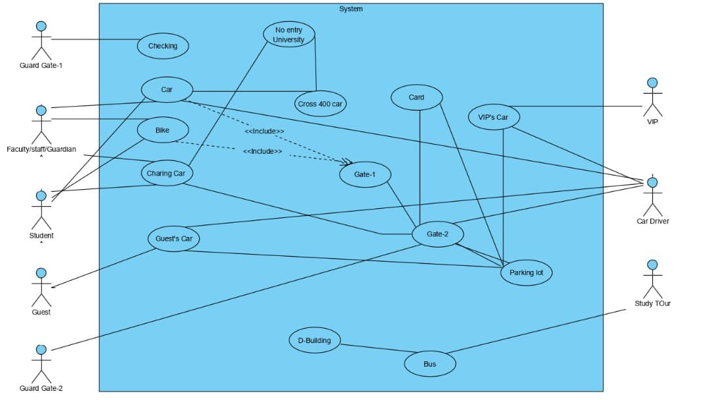

**2. Class Diagram**

Does the Class diagram include the major classes (attributes, operations) and the relationship among the classes needed to deliver by the system?

The Class diagram includes the major classes (attributes, operations) and the relationship among the classes needed to deliver by the system.

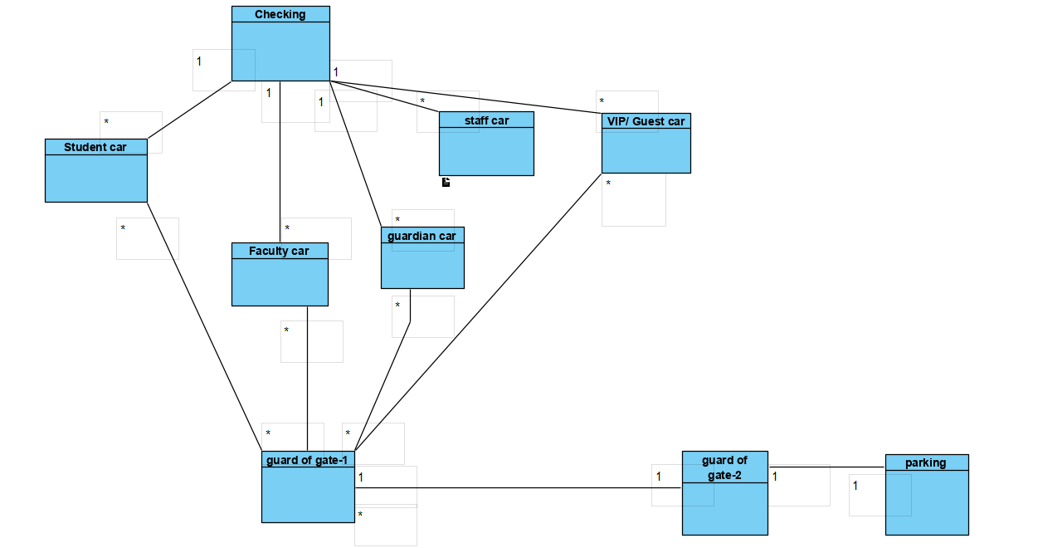**3. State Chart Diagram**

Does the state chart diagram include the major activities needed to deliver by the system?

A Statechart diagram describes a state machine. State machine can be defined as a machine which defines different states of an object and these states are controlled by external or internal events.The state chart diagram includes the major activities needed to deliver by the system.

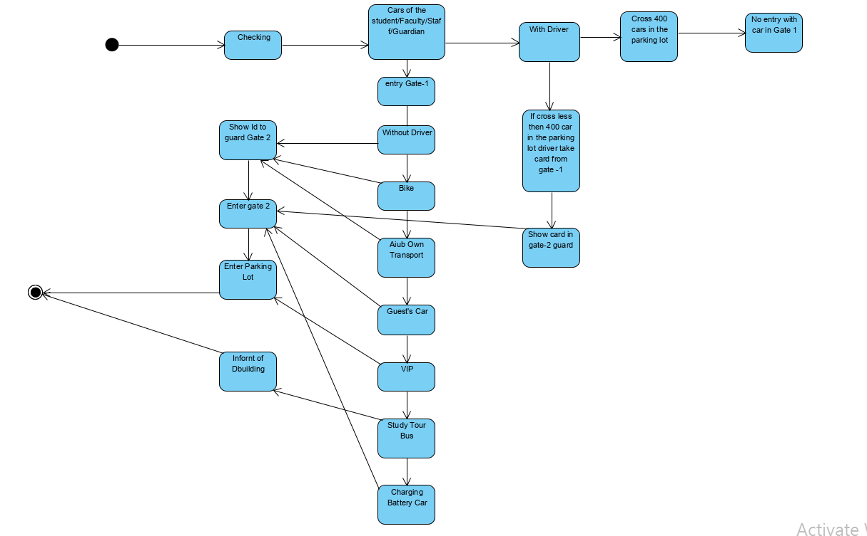**4. Activity Diagram**

Does the Activity diagram include the major activities needed to deliver by the system?

Activity diagram is another important behavioral in UML diagram to describe dynamic aspects of the system. Activity diagram is essentially an advanced version of flow chart that modeling the flow from one activity to another activity.

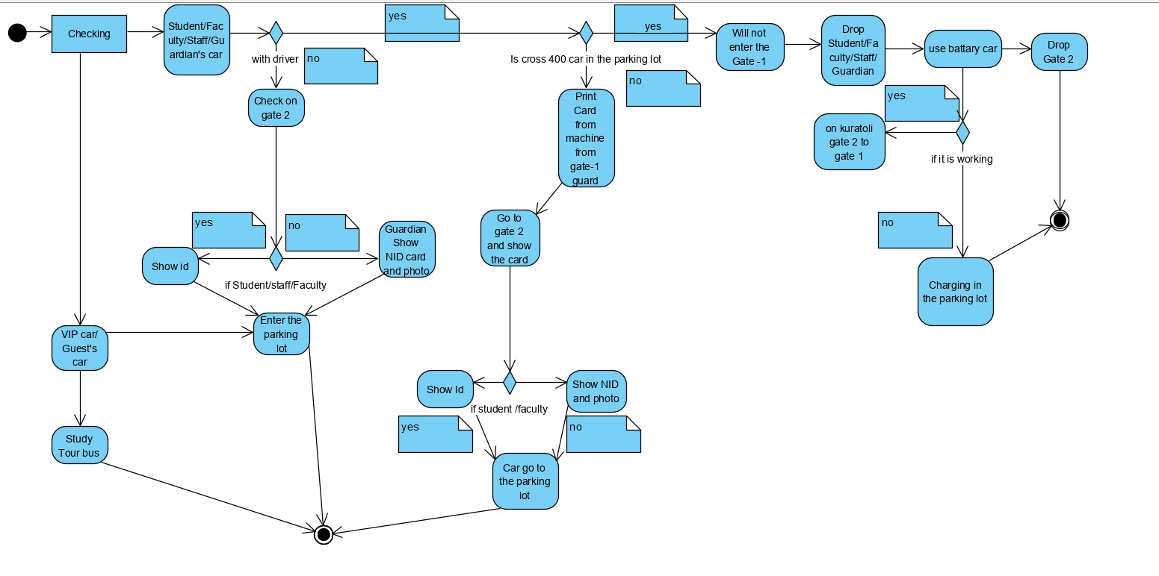

**5. Sequence Diagram**

Does the Sequence diagram include the sequence of the major activities needed to deliver by the system?

Sequence diagrams, commonly used by developers, model the interactions between objects in a single use case. They illustrate how the different parts of a system interact with each other to carry out a function, and the order in which the interactions occur when a particular use case is executed.The Sequence diagram includes the sequence of the major activities needed to deliver by the system.

